Sri Lanka Institute of Information Technology



Assignment 1

G3 S1_04

On Road Vehicle Breakdown Assistance

**Internet and Web Technologies – IT1100**

B.Sc. (Hons) in Information Technology

**Group Details**

Group Number: 04

Project Title: On Road Vehicle Breakdown Assistance

|  |  |  |  |  |
| --- | --- | --- | --- | --- |
|  | Student ID | Student Name | Email | Contact Number |
| 1 | IT18107388 | Perera D.F.Y.D | dananjayaperera655@gmail.com | 077-3355142 |
| 2 | IT18106916 | Malagala D.S.K | saveen.kulanjith@gmail.com | 071-3948232 |
| 3 | IT18107210 | Seekkubadu D.P. | dileepapavel98@gmail.com | 071-4874053 |
| 4 | IT18107074 | Upulie H.D.I | ireshaupulie@gmail.com | 071-4978151 |
| 5 | IT18107524 | Thariq A.L.M | thariqlatheef@gmail.com | 077-4169614 |

# **Introduction**

In-order to achieve higher levels of profitability, efficiency and productivity as a business it’s sagacious to use information systems to perform better in any sector of work. In a world where convenience plays a bigger role than the value, owning a private automobile has become almost customary. The status, liberty and independence that comes along with owning a car, are always followed by the responsibilities and breakdowns that could occur alongside the road.

Although good vehicle maintenance could go a long way to avoiding breakdowns, it’s not a guarantee. Breakdowns could occur in an unfamiliar area and when a person least expects. This is when “On Road Vehicle Breakdown Assistance” could be beneficial.

With on road vehicle breakdown assistance services like roadside recovery, roadside rescue or on-demand gas delivery is simply at a person’s fingertips. Companies like AA, Breakdown Assist, Admiral, AXA, Emergency Assist Ltd, Allianz, NRMA are some of the reputable companies on this sector.

# 

Personas

**Owner**



* Name: Dhammika Dissanayake
* Age: 45
* Gender: Male
* Motivation: To invest in a company and gain a higher profit.
* Goals: To build himself a brand name.

Hiring more experienced companies in the field.

**Administrator**



* Name: Isuri Rajapaksha
* Age: 27
* Gender: Female
* Motivation: To make every road journey safe and to build a trust between travelers and our company.
* Goals: Become one of the top companies in the country.

To make an efficient employee system within the company.

**Financial Executive Officer**



* Name: Chamal Perera
* Age: 29
* Gender: Male
* Motivation: To be a part of much larger group than myself and to build a reputation for myself.
* Goals: To build a high functional system within the company to handle the financials.

**Technician**

* Name: Naveen Jayasinghe
* Age: 42
* Gender: Male
* Motivation: To perform a better, faster, accurate service.
* Goal: Become a senior technician in 3 to 5 years.

Achieve a salary of Rs.60 000 to he can afford a better house.

**Customer**



* Name: Sawandi Balasooriya
* Age: 25
* Gender: Female
* Motivation: Fast and effective service from the company.
* Goals: Getting the problem solved as quickly as possible.

# **User Journeys**

<<Use following format for all **5 user journeys**>>

* Example: Persona-Customer User Journey-Purchasing a book

Login to the site

Search books

Land on the site via online advertisement

Confirm purchasing

Add payment details

* Persona- User Journey-
* Persona- User Journey-
* Persona- User Journey-
* Persona- User Journey-

# **Wire Frames**

* Home Page

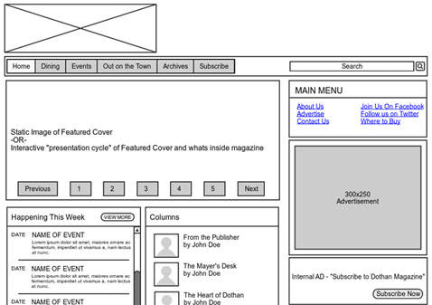

* Registration Page

* Login Page
* Contact Us Page
* User Account Page

**<<Note: Include wireframes for all the pages in your proposed web application. If you have identified more pages other than above pages, please include them as well. >>**

# **Individual Contribution**

|  |  |  |  |
| --- | --- | --- | --- |
|  | **Student ID** | **Student Name** | **Individual Contribution** |
| 1 | IT18107388 | Perera D.F.Y.D | * Persona: Owner * User Journey: Owner * Wireframe : Sign Up |
| 2 | IT18106916 | Malagala D.S.K | * Persona: Customer * User Journey: Customer * Wireframe: FAQ |
| 3 | IT18107210 | Seekkubadu D.P. | * Persona: Administrator * User Journey: Administrator * Wireframe: |
| 4 | IT18107074 | Upulie H.D.I | * Persona: Technician * User Journey: Technician * Wireframe: |
| 5 | IT18107524 | Thariq A.L.M |  |